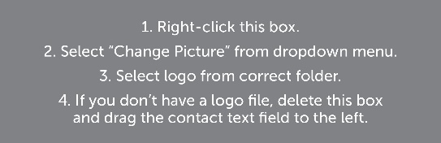

**Insert Name Here**

1234 Street Address, City, ST 12345  
**P:** (888) 888-8888  
**E:** name@emailaddress.com